**DAILY ONLINE ACTIVITIES SUMMARY**

|  |  |  |  |  |  |  |  |  |
| --- | --- | --- | --- | --- | --- | --- | --- | --- |
| **Date:** | **27-05-2020** | | | | | **Name:** | **RAVALI P** | |
| **Sem & Sec** | **6 B** | | | | | **USN:** | **4AL17CS076** | |
| **Online Test Summary** | | | | | | | | |
| **Subject** | | **SSCD** | | | | | | |
| **Max. Marks** | | **30** | | **Score** | | | **24** | |
| **Certification Course Summary** | | | | | | | | |
| **Course** | **CARRER EDGE** | | | | | | | |
| **Certificate Provider** | | | **TCS** | | **Duration** | | | **15 DAYS** |
| **Coding Challenges** | | | | | | | | |
| **Problem Statement-Python program to check palindrome or not.**  **Python program to print numbers that are not divisible by 2 or 3 and lie between 1 and 50.** | | | | | | | | |
| **Status:Executed** | | | | | | | | |
| **Uploaded the report in Github** | | | | | **Yes** | | | |
| **If yes Repository name** | | | | | **https://github.com/Ravalipr/Daily-Status.git** | | | |
| **Uploaded the report in slack** | | | | | **Yes** | | | |

Online Test Details: (Attach the snapshot and briefly write the report for the same)

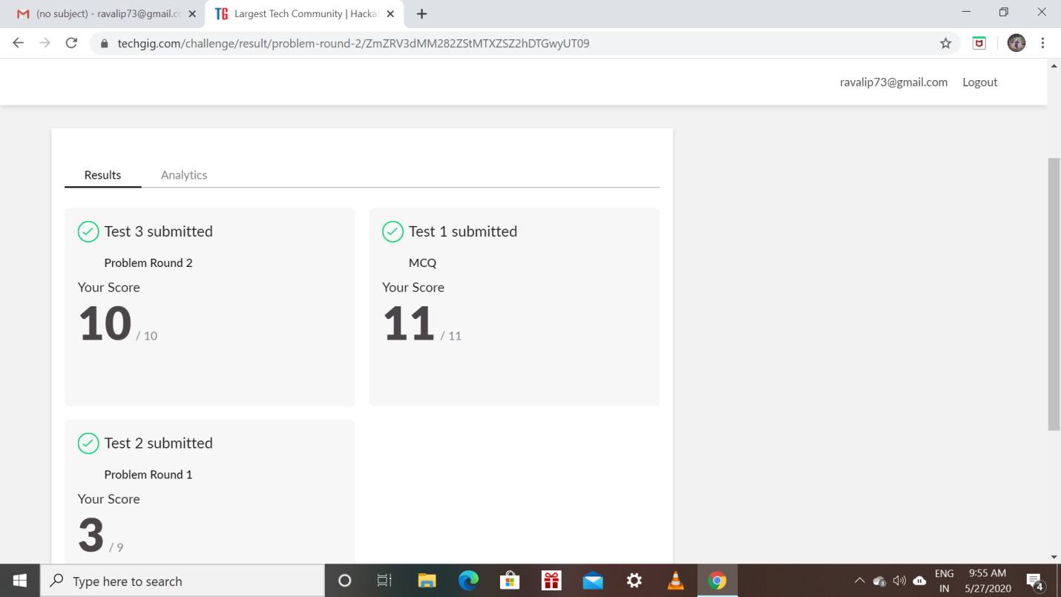

Certification Course Details: (Attach the snapshot and briefly write the report for the same)

* Todays topic on certification course I have been learnt about the resume preparation.
* How essential the cover page of the resume.
* What and all to be included in the resume .
* Atlast they have given assignment to based on the resume writing.
* And one more topic I have learnt today is about the how to face Group Discussions.
* How we should actively be involved in the group discussions.

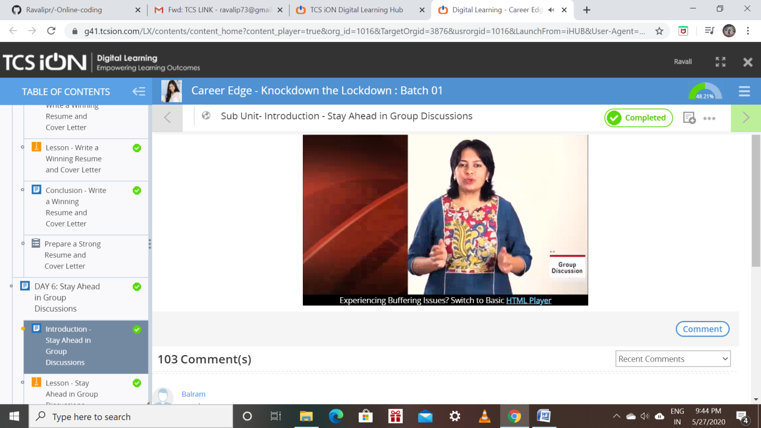

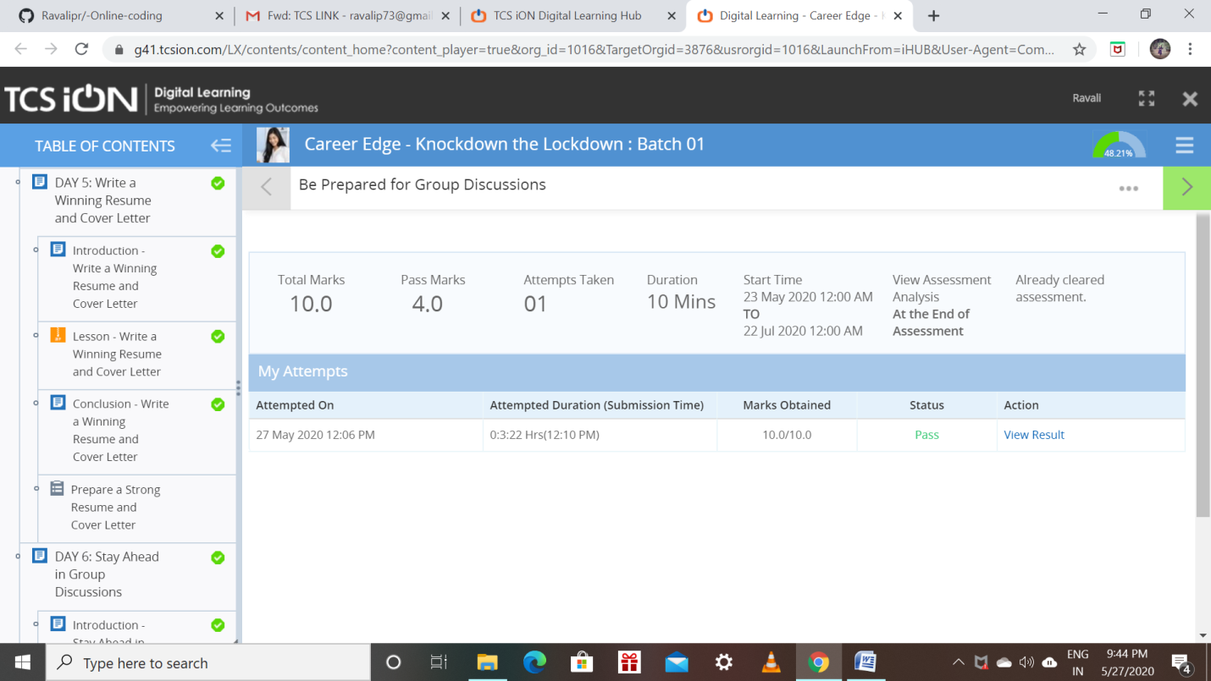

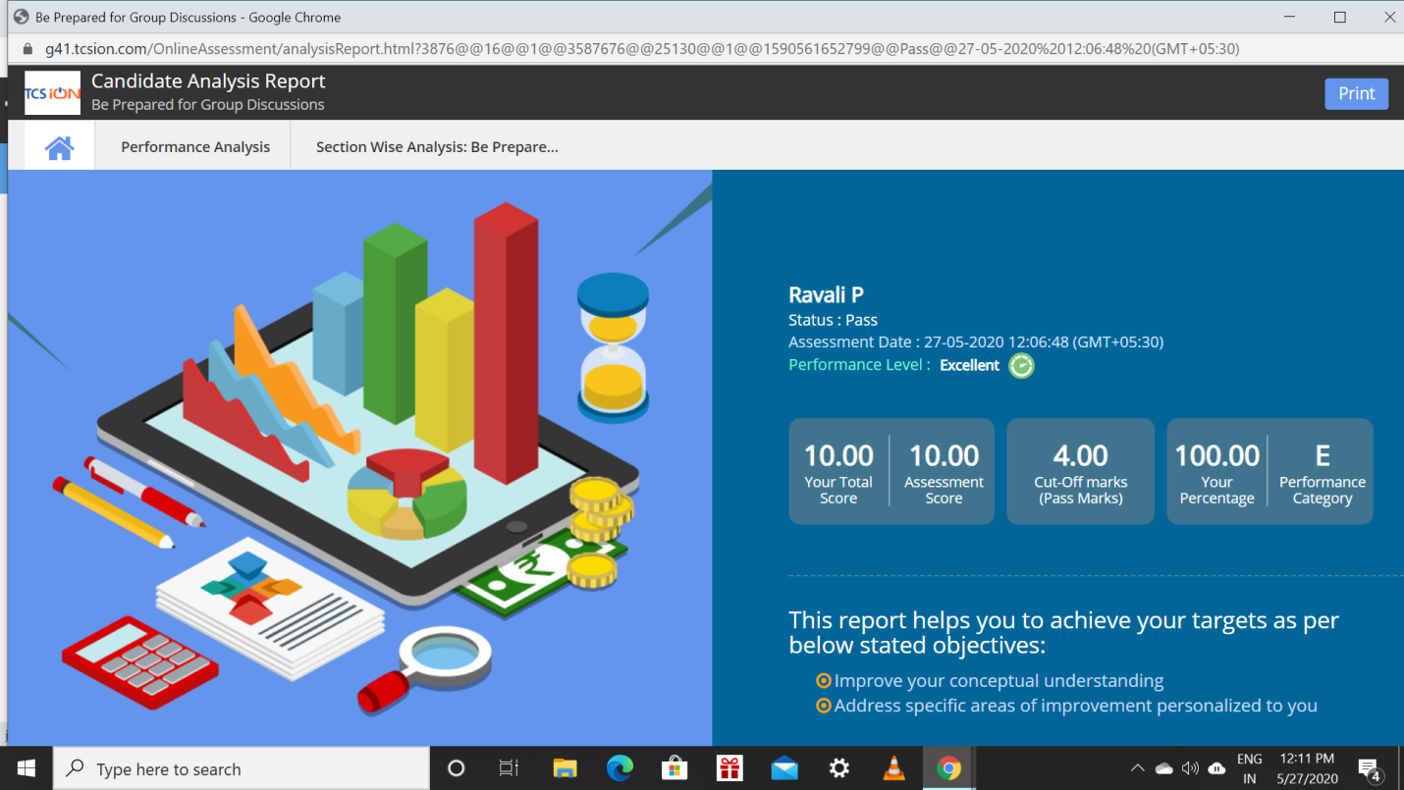

Coding Challenges Details: (Attach the snapshot and briefly write the report for the same)

Program1:

* The first python program is about to print all integers that are not divisible by 2 and 3 but they lie in the range between 1 and 50

Program 2:

* The second program is to find whether a number is a palindrome or not a palindrome.

